**ASSIGNMENT COVER SHEET**

For use with online submission of assignments

Please complete all of the following details and then make this sheet the **first page of each file of your assignment – do not send it as a separate document.**

Your assignments must be submitted as either **Word documents, text documents with .rtf extension or as .pdf documents**. If you wish tosubmit in any other file format please discuss this with your lecturer well before theassignment submission date.

|  |  |
| --- | --- |
| Student Name: | **Yu Bai** |
| Student ID No.: | **24274889** |
| Unit Name: | ISYS3001 Managing Software Development |
| Unit Code: | ISYS3001 |
| Tutor’s name: | **Zhenjin Huang** |
| Assignment No.: | Assessment 2 |
| Assignment Title: | Practical Skills |
| Due date: | 25 September 2023 11:59 PM (AEST) |
| Date submitted: | **2023/9/24** |

Declaration:

*I have read and understand the Rules Relating to Awards ([Rule 3 Section 18 – Academic Misconduct Including Plagiarism](http://policies.scu.edu.au/view.current.php?id=00140" \l "s18)) as contained in the SCU Policy Library.   
I understand the penalties that apply for plagiarism and agree to be bound by these rules. The work I am submitting electronically is entirely my own work.*

|  |  |
| --- | --- |
| Signed: | Yu Bai |
| (please type your name) |  |
| Date: | 2023/9/24 |

**Screen capture**

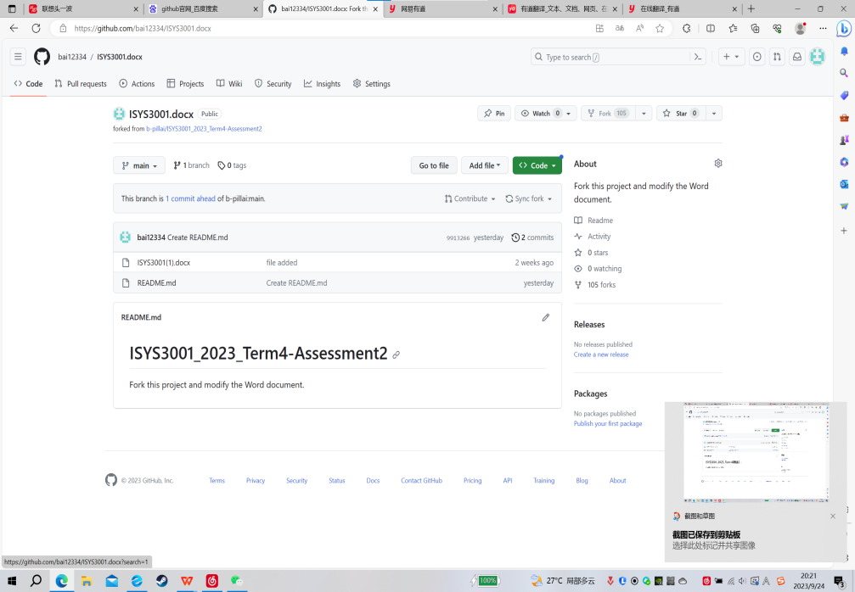

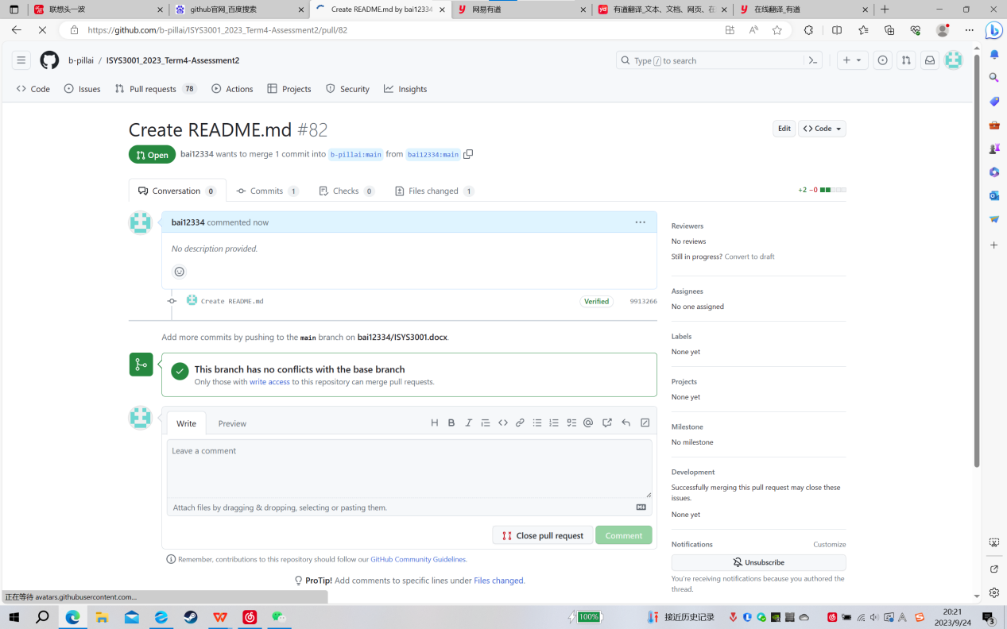

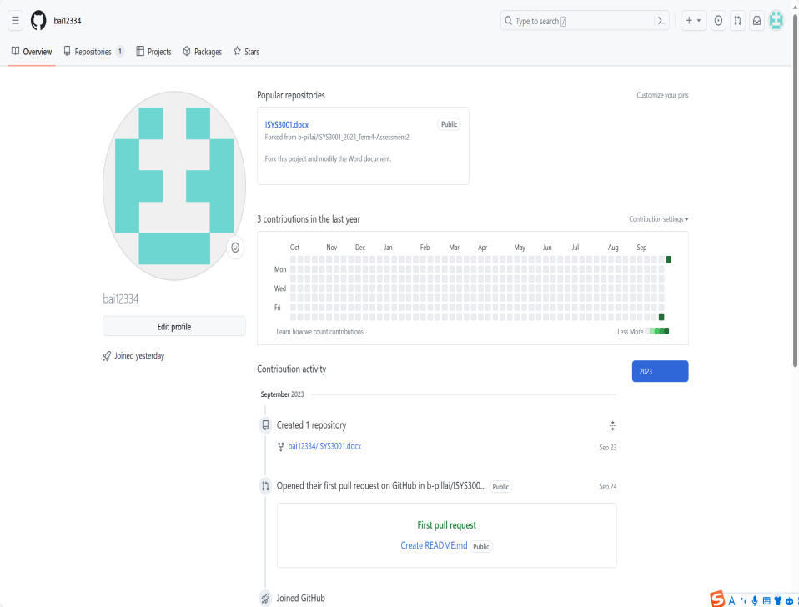

**Configuration management**

**Suggestion:**

1. **Change management**

Make everyone aware of the goal of simplifying the software development process to minimize conflicts and errors in software development projects, and understand their responsibilities, tasks, and timelines. Find problems and deficiencies in the process of change, and actively communicate and solve them. Consider the resources required for change, such as human, technical, financial, time and other aspects of adjustment. Develop and establish a change plan. What are the existing advantages and how to make full use of them to promote change; Analyze what your weaknesses are and actively discuss making changes to turn them into strengths. During the whole process of change, actively ask employees and customers for their views and opinions on the change, integrate and make adjustments. Make sure there is strong support for change from the top, middle and bottom. At the executive level of the organization, there is a sound plan and implementation procedures and a clear understanding of possible obstacles and obstacles. Strengthening staff training. There are professional responsible persons to monitor, improve and integrate the entire software development process, and carry out reasonable allocation of resources.

1. **Version management**

Choose a version control system that fits your team's needs. When choosing a version control system, consider factors such as the needs of the team, the number of people, and the size of the development. Conduct reasonable branch management. Manage code specification, annotate code, specify variable naming rules and code structure. Regular code review, set up the corresponding review mechanism in the version library, check the correctness and integrity of the code, so that the software development team staff can easily change and repair the code. Conduct version tracking and updating, set up version tracking and updating mechanism in the version library, track software version and update records, facilitate software developers to find problems and improve software development efficiency. Unified and coordinated management of various versions, effective record of the evolution process of different versions and effective management of different versions, ensure the logical consistency and relative independence of different versions, and will not make software developers work in isolated islands.

1. **system construction**

Software developers at all levels need to understand the requirements and constraints of the project and work toward the same goal. This includes business requirements, technical requirements, security and privacy requirements, and so on. When building a software system, the system needs to be broken down into different modules, each module responsible for different functions and business logic. At the same time, it is necessary to ensure that the interface between these modules is reasonably designed to ensure the scalability and maintainability of the system and facilitate the integration of developers. Training for software developers, so that software developers pay attention to code quality and specification, as far as possible to avoid hard coding and copy and paste and other bad development habits, to ensure the readability and maintainability of code. Use a unified system architecture building style. By using modular design, following design patterns, and using open standards. Practice agile development methods. Use visual tools to help design and communicate system architecture. Use open source components and frameworks to accelerate the development process and improve the quality and reliability of the system. Perform continuous integration and automated testing to ensure code quality and stability.

1. **Release management**

Attach importance to release management, and compile, test and document the code in the release branch to ensure the integrity and executable of the code, so that software developers can integrate operations more effectively. For continuous integration and delivery, use continuous integration tools. In order to meet the changing needs of users, as well as to fix bugs and bugs in software, companies should develop a strategy to release updates regularly. Determine the frequency of updates based on the complexity of the project and the functionality of the software. In order to accurately track and identify different versions of software, companies need to set up a version number management mechanism. Users may encounter various errors and problems in the process of using the software, and the company needs to respond to user feedback in time, and establish a set of error handling and feedback mechanism. To ensure a smooth software release, companies need to establish a release process and standardize the tasks and responsibilities at each stage. The release process should include compiling, building, testing, deploying, and validating the software, each with a clear task and related documentation.

**Request for proposals(RFP)**

**Objective**: To develop an integrated, multifunctional system to support several ABB locations.

**Background** :ABB is a company that sells various electronic products, and provides post-repair and various accessories. Now they need an integrated system to help the company's operations, so that the company can have better growth.

**System functions**:

1. Establish a customer information database system, which includes the relevant information of various products, such as functions and how to use, including other attached services, after-sales and return visits. And the database will also store all kinds of maintenance information, record all kinds of information about the customer, history of any product purchased by the customer, reports of various problems that have occurred, and records of what the staff has done. The database will organize all of these information, which is convenient for the work of software developers and the management of senior management of companies.
2. Establish a multi-functional marketing system that can help staff carry out traditional marketing as well as digital marketing through email, social media, we-media or other existing advanced marketing technologies. This system can call the information in the customer information database, which is convenient for enterprise marketing. At the same time, the system can also input customer information and automatically enter the customer information database.
3. Establish an inventory management system, which can query the information of products for sale, as well as the information of parts needed for maintenance, and can also be used by wholesalers for automatic ordering. This system can query all products and parts at any ABB location, and can be deployed to give the best solution.
4. This system can integrate three systems, customer information database system, marketing system and inventory management system, and optimize the entire system and allocate resources reasonably. Moreover, the sub-system has a super algorithm and can provide reports of various data information. And you can check the company's operation regularly in order to make corresponding adjustments and management decisions.
5. This system is very intelligent and a collection of multiple systems, which can provide strong support for the later development of ABB company.

**Evaluation criteria**:

1. Whether it can meet the needs of ABB Company

2. Whether it can solve some existing difficulties of ABB Company

3. Whether it can meet ABB's requirements for system functions

4. Whether it can increase ABB's sales and profits

5. Whether it can improve the efficiency of ABB

6. Whether it is in line with ABB's budget

7. Whether the design of the software is professional, simple and convenient, and easy for users and staff to use.

8. Whether the company's ability meets the standard and can be completed on time

9. Whether the company's previous projects stood out

10. Whether the algorithm of the system is strong enough to avoid too many errors

11. Whether the system is secure and can withstand network attacks

12. Whether the storage of data is safe, and whether the security of company and user information can be guaranteed.

13. Whether the efficiency of the system is high enough that there will not be too long waiting.

**More details of the project**:

Supplier company information introduction, address, contact information.

The project leader of the supplier company's relevant information, competence, historical service, contact information.

The supplier provides the initial project proposal, as well as the professional system function supplement and suggestion.

This section describes the system upgrade direction and solution.

Schedule and schedule of the whole project process.

We need assistance from ABB in the later stage.

Provide task lists based on system functions.

Provide multiple specific budget proposals, as well as proposals for later development and maintenance costs.

Specific design plan, including several major changes and small changes, design prototype time.

**Contact information**:

Tel: 13012019733

Email: [13012019733@qq.com](mailto:13012019733@qq.com)

**Budget**:

$10,000 for Phase 1, 2023/10/1

$5,000 for Phase 2, 2023/10/7

Final stage $5,000, 2023/10/14

**Timeline**:

RFP start time: 2023/9/25

Proposal closing time 2023/9/28

Discussion using vendor results published on 2023/9/30

Project start time: 2023/10/1